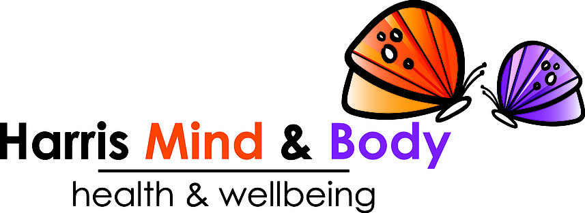
Harris Mind & Body (HMB) Clothing Order Form

Order number (staff):

Your Name:

Date of order:

Contact Details:

Quantity | Item Name / Description | Item Code | Colour | Size | Slogan | Text Colour | Fee | Special request?  Text on back?  Give lots of detail! | Extra Fee | Cost
1 | (5)  Freedom T-Shirt  Example | AV130 | Dusty Rose | S = 10 - 12 | (13)  No Pilates  No Champagne | Gold | £23 | *Sarah Loves Pilates  *Large on the back in gold text.  *Title case  *Same font as on the front. | £4 | £27
Total:

Paid:
(Staff: please state the method and date of payment)

